

### Semester Two Examination, 2020

### Question/Answer booklet

# MATHEMATICS

Circle your teacher’s initials

SWA JIB IFB

AGC STL SAV

**METHODS**

**UNITS 1&2**

## Section Two:

## Calculator-assumed

(Booklet 3 of 3)

Your name

## Time allowed for this section

Reading time before commencing work: ten minutes

Working time: one hundred minutes

## Materials required/recommended for this section

***To be provided by the supervisor***

TWO Question/Answer booklets (Booklets 2 and 3)

Formula sheet (retained from Section One)

***To be provided by the candidate***

Standard items: pens (blue/black preferred), pencils (including coloured), sharpener,  
correction fluid/tape, eraser, ruler, highlighters

Special items: drawing instruments, templates, notes on two unfolded sheets of A4 paper, and up to three calculators approved for use in this examination

## Important note to candidates

No other items may be taken into the examination room. It is **your** responsibility to ensure that you do not have any unauthorised material. If you have any unauthorised material with you, hand it to the supervisor **before** reading any further.

## Structure of this paper

|  |  |  |  |  |  |
| --- | --- | --- | --- | --- | --- |
| Section | Number of questions available | Number of questions to be answered | Working time (minutes) | Marks available | Percentage of examination |
| Section One: Calculator-free | 8 | 8 | 50 | 52 | 35 |
| Section Two: Calculator-assumed | 12 | 12 | 100 | 90 | 65 |
|  | | |  | **Total** | 100 |

## Instructions to candidates

1. The rules for the conduct of examinations are detailed in the school handbook. Sitting this examination implies that you agree to abide by these rules.

2. Write your answers in this Question/Answer booklet preferably using a blue/black pen.  
Do not use erasable or gel pens.

3. You must be careful to confine your answers to the specific question asked and to follow any instructions that are specific to a particular question.

4. Show all your working clearly. Your working should be in sufficient detail to allow your answers to be checked readily and for marks to be awarded for reasoning. Incorrect answers given without supporting reasoning cannot be allocated any marks. For any question or part question worth more than two marks, valid working or justification is required to receive full marks. If you repeat any question, ensure that you cancel the answer you do not wish to have marked.

5. It is recommended that you do not use pencil, except in diagrams.

6. Supplementary pages for planning/continuing your answers to questions are provided at the end of this Question/Answer booklet. If you use these pages to continue an answer, indicate at the original answer where the answer is continued, i.e. give the page number.

7. The Formula sheet is not to be handed in with your Question/Answer booklet.

Question 16 (7 marks)

A reader bought $16$ different novels, planning to read a selection of them when on holiday.

(a) Determine the number of different combinations of novels the reader could choose from if they select:

(i) seven novels (1 mark)

(ii) seven or eight novels. (2 marks)

Five of the $16$ different novels are by the author Hay.

(b) The reader makes a random selection of seven novels. Determine the probability that:

(i) none of the novels selected are by Hay (2 marks)

(ii) four of the novels selected are by Hay. (2 marks)

Question 17 (13 marks)

A small body is moving in a straight line. Relative to a fixed point $O$, it has a displacement of $x$ cm at time $t$ seconds given by

$$x(t)=2t^{3}-28t^{2}+98t-72, 0≤t≤10.$$

(a) Obtain an expression for the velocity of the body in the form $v\left(t\right)=a(bt+c)(t+d)$, where $a, b, c$ and $d$ are integer constants. (3 marks)

(b) Determine:

(i) the initial velocity of the body (1 mark)

(ii) the displacement of the body at the instant(s) that it is stationary. (3 marks)

(c) Use the axes below to sketch the displacement of the body over the given domain.

Label all important points.

(3 marks)

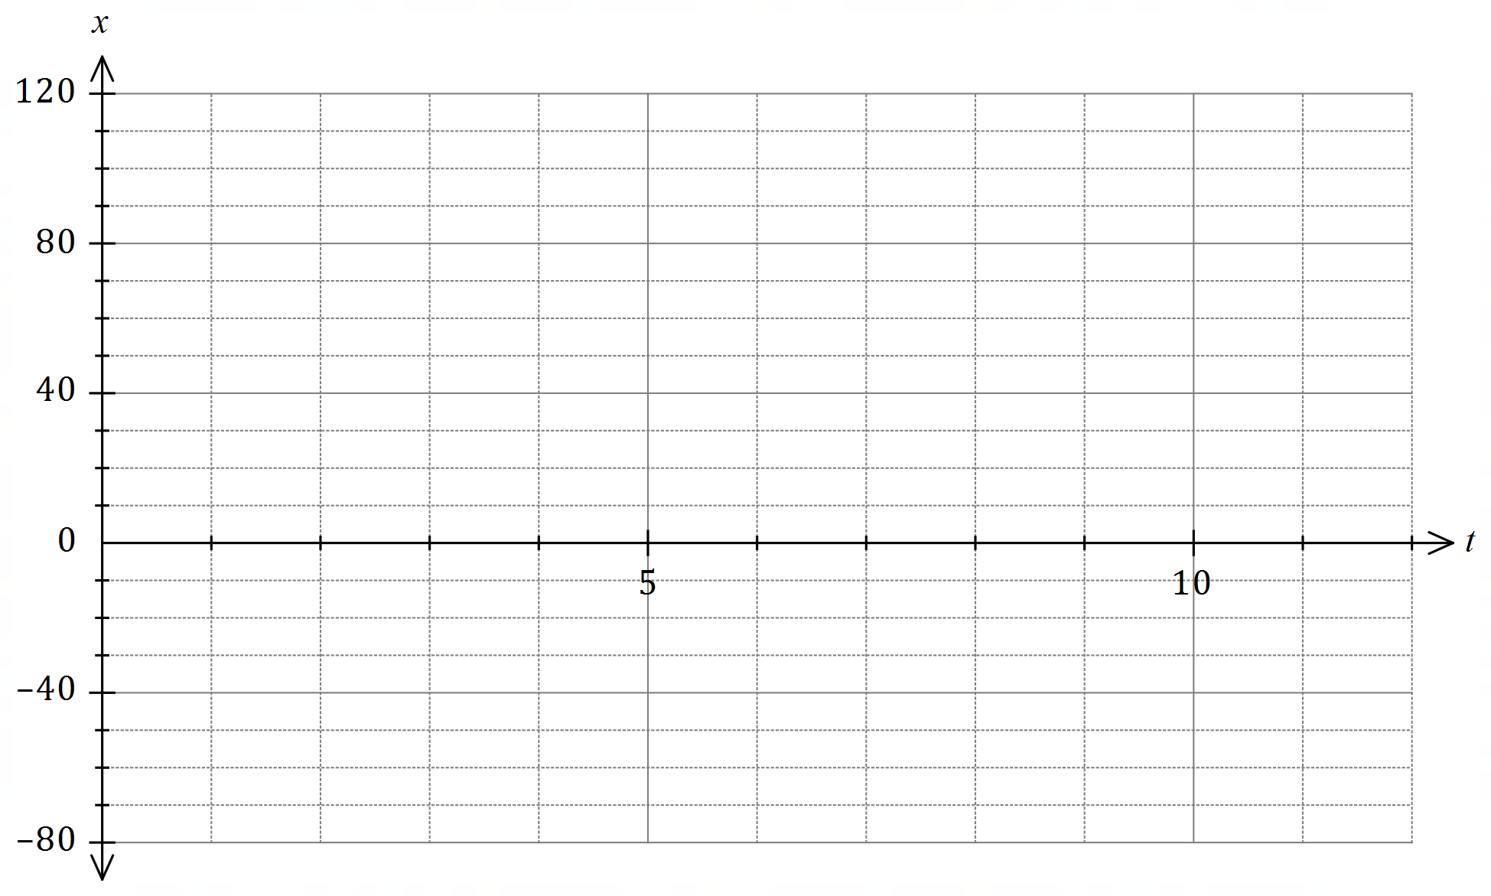

(d) State the number of times the body passed through $O$ and determine the minimum speed and maximum speed of the body as it passed through this point. (3 marks)

Question 18 (9 marks)

(a) Point $A(11, -5)$ lies on the circumference of a circle with centre $(-4, 3)$. Determine the equation of the circle. (3 marks)

(b) The graph of $y=1+\begin{matrix}a \\ \overline{x+b}\end{matrix}$ passes through the points $(1, -2)$ and $(3, 4)$.

(i) Determine the value of each of the integer constants $a$ and $b$ (3 marks)

(ii) Draw the graph of $y=1+\begin{matrix}a \\ \overline{x+b}\end{matrix}$ on the axes below, clearly indicating any asymptotes. (3 marks)

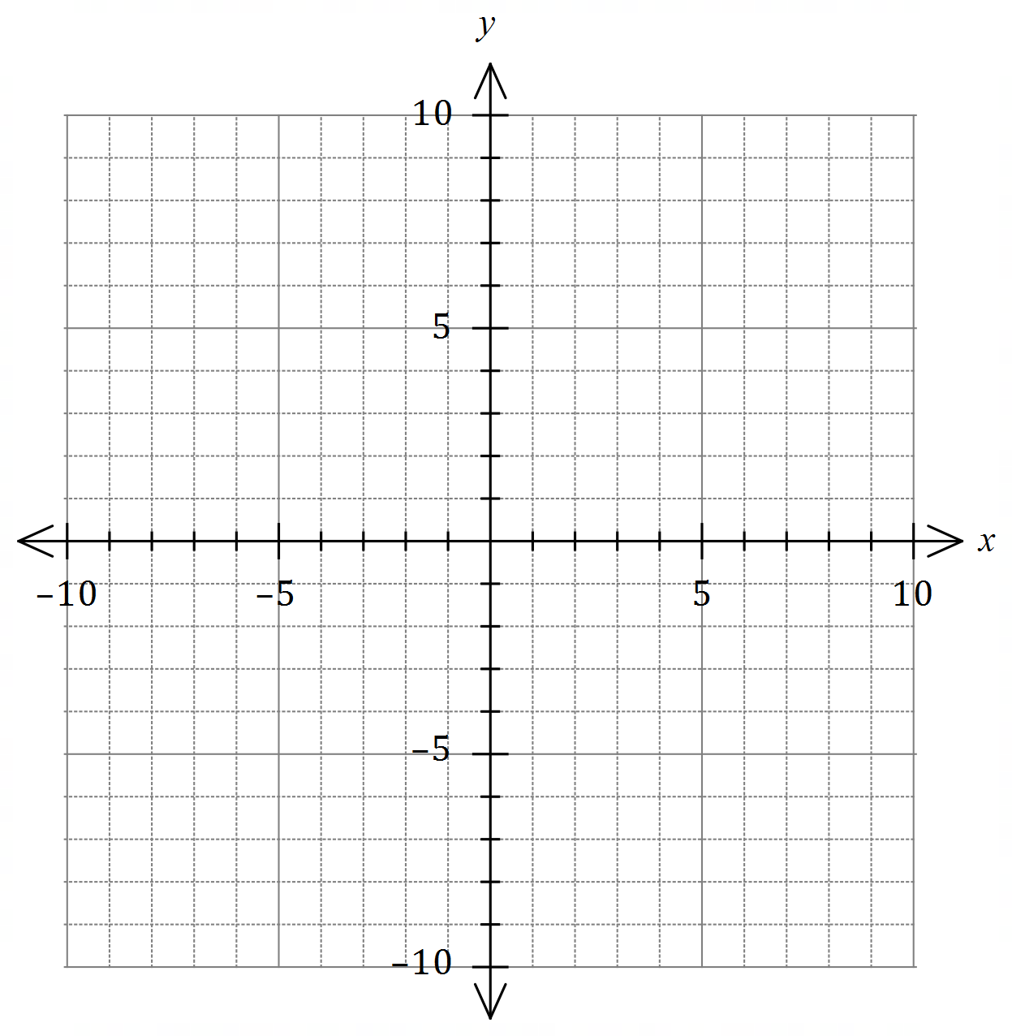

Question 19 (8 marks)

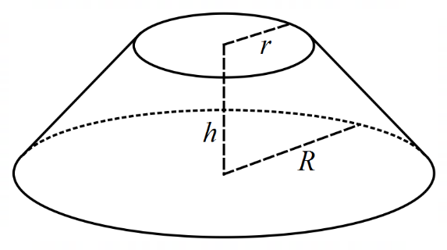The frustum shown at right is a truncated right cone.

The volume of such a solid is $V=\begin{matrix}πh \\ \overline{ 3 }\end{matrix}(r^{2}+R^{2}+rR)$,  
where $r$ is the radius of the smaller circle, $R$ is the  
radius of the larger circle and $h$ is the perpendicular  
distance between the two parallel circles.

Consider frustum $F$ where $r=x$ cm, $R=2r$ 
 and $r+h=45$ cm.

(a) Show that the volume of frustum is cm3. (3 marks)

(b) Use a calculus method to determine the value of $x$ that maximises the volume of frustum $F$ and state this maximum volume, rounding your answer to the nearest cm3. (5 marks)

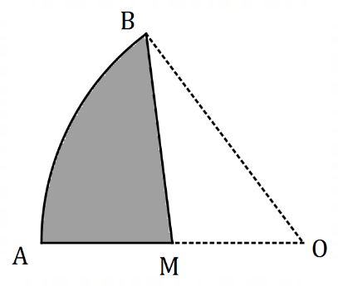Question 20 (8 marks)

The shaded region $ABM$ in the diagram is a  
canvas awning and is part of a sector of  
circle $OAB$ with centre $O$ and radius $3.2$ m.

$BM$ is a straight line from $B$ to $M$, the  
midpoint of $OA$.

The size of $∠AOB$ is $1.3$ radians.

(a) Determine the area of sector $OAB$. (1 mark)

(b) Determine the area of the canvas awning. (3 marks)

(c) The edge of the canvas is to be reinforced with thin wire. Determine the length of wire required. (4 marks)

Supplementary page

Question number: _________

Supplementary page

Question number: _________

Supplementary page

Question number: _________

© 2020 WA Exam Papers. Hale School has a non-exclusive licence to copy and communicate this document for non-commercial, educational use within the school. No other copying, communication or use is permitted without the express written permission of WA Exam Papers. SN035-162